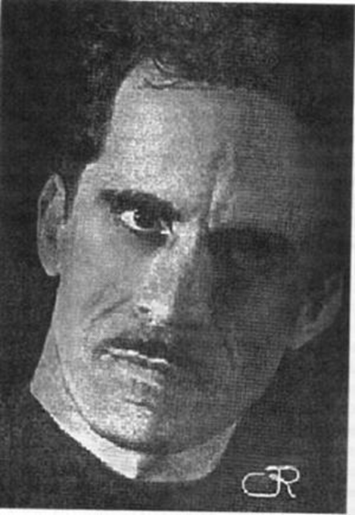

Image 1.

Photograph of Francisco Morín Vidán found at:

<http://www.encaribe.org/es/Picture?IdImagen=5270&idRegistro=1470>

No photo credit available.

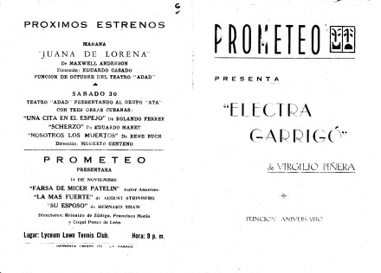

Image 2.

Program from the first production of *Electra Garrigó* by Teatro Prometeo. From the Theater Ephemera Digital Collection at University of Miami. Found at: <http://ctda.library.miami.edu/digitalobject/561>

Note: This particular item does not appear to be copyrighted. More information about their policy can be found here: [University of Miami copyright policy](http://ctda.library.miami.edu/copyright)